Pair Share

- Partner A will explain to partner B how you would answer question #1 in column A.
- Partner B will explain to partner A how to answer question #1 in column B.
- The process is repeated for each question number.
Partner A | Partner B
1. What is the x-intercept for the function?  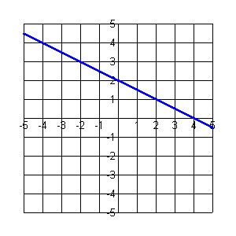 | 1. What is the x-intercept for the function?  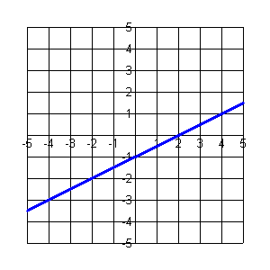
2. Sketch a linear function with an  x-intercept of -3.  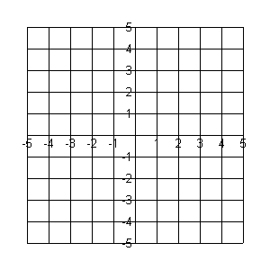 | 2. Sketch a linear function with an  x-intercept of 1.
3. Solve the equation $x+6=0$. | 3. Solve the equation $x−5=0$.
4. Given $f(x)=x+6$, evaluate $f(−6)$. | 4. Given $f(x)=x−5$, evaluate $f(5)$.
5. Graph the function $y=x+6$.  State the x-intercept. | 4. Graph the function $y=x−5$.  State the x-intercept.

