What Do I Need?
- a pencil/pen
- a paper airplane
- a sheet of grid paper
- a calculator
Procedure

- Measure the distance from your shoulders to the ground in inches. _______

- Multiply the height times 2.54. _______ (This measurement is your launch height.)

- Complete the following table when testing your paper airplane.

- Graph the average distance flown and launch height on the grid sheet.

Name of Plane:
Trial Number | Distance Flown (D)  (cm) | Launch Height (H)  (cm) | Glide Ratio (G)
1
2
3
4
5
6
Average
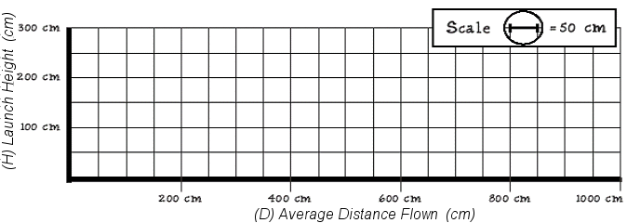

Debriefing Questions

- What is the average angle of depression? ____________________________________

- What types of triangles were created while making the airplane?

_________________________________________________________________________

_________________________________________________________________________

- Is the glide ratio the slope of the line? Explain why or why not.
_________________________________________________________________________

