term | In words | With pictures
domain |  | 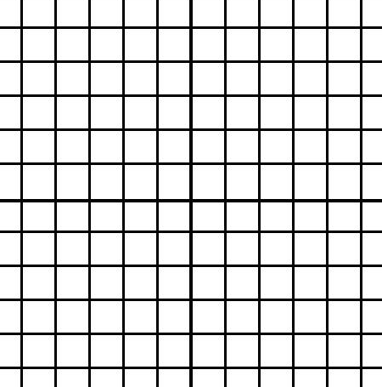
range
end behavior
minimum
maximum
rate of change
x-intercept
y-intercept
interval of increasing
interval of decreasing
C
H
A
R
A
C
T
E
R
I
S
T
I
(MCC9-12.F.BF.1;
MCC9‐12.F.IF.4; MCC9‐12.F.IF.5; MCC9‐12.F.IF.6; MCC9‐12.F.IF.7a; MCC9‐12.F.IF.7e)
Dr. Jennifer L. Brown, © 2014, Columbus State University,
Columbus, Georgia)
C
S

