
Tootsie Fable, "How Many Licks"
30 Second Commercial
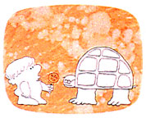 |  | 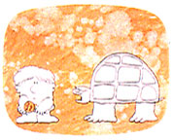 |  | 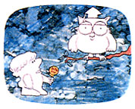
Mr. Turtle, how many licks does it take to get to the Tootsie Roll center of a Tootsie Pop? |  | I never made it without biting, ask Mr. Owl. |  | Mr. Owl, how many licks does it take to get to the Tootsie Roll center of a Tootsie Pop?
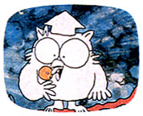 |  | 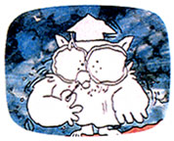 |  | 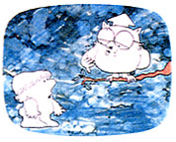
Let's find out. One, two, three. |  | Crunch |  | Three
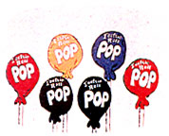 |  | 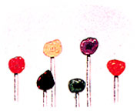 |  | 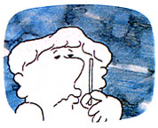
How many licks does it take to get to the Tootsie Roll center of a Tootsie Pop? |  | Crunch |  | The world may never know.

Tootsie Roll Industries is aware of three scientific studies that have been conducted to determine how many licks it takes to reach the center of a Tootsie Pop.
- A group of engineering students from Perdue University recorded that a licking machine, modeled after a human tongue, took an average of 364 licks to get to the center. They tried the same licking test on 20 volunteers, and found that the average licks to the center were 252.
- A chemical engineering doctorate student at the University of Michigan recorded that his licking machine required an average of 411 licks.
- A group of students at Swarthmore School did an in-school experiment using humans, and determined that it took an average of 144 licks to get to the center.

Materials: Tootsie Pops, scales

Questions:

1. How many licks do you think that it will take to get to the chocolate center of the pop without crunching it?

2. When you enjoy a Tootsie Pop, what constitutes a lick?

3. For this experiment a lick will be defined as

Procedure:

4. Weigh your candy sucker. Weight = _____________

5. Keep tally of the number of licks it takes to have one side has the chocolate center completely revealed. _____________________________________________________________________
_____________________________________________________________________________
Number of licks = ___________

6. Now record the weight and lick number from each class member.

  Person | Candy weight | # of licks
  1 | . | .
  2 | . | .
  3 | . | .
  4 | . | .
  5 | . | .
  6 | . | .
  7 | . | .
  8 | . | .
  9 | . | .
  10 | . | .
  Person | Candy weight | # of licks
  11 | . | .
  12 | . | .
  13 | . | .
  14 | . | .
  15 | . | .
  16 | . | .
  17 | . | .
  18 | . | .
  19 | . | .
  20 | . | .
Analysis:

7. Make a scatter plot of the data in the table in question 6. Make sure that you number the line evenly.

8. Calculate the mean number of licks.

9. Find the regression line for the data. y-hat = _________________________________
y-bar = _________ (average licks)
r = _________ (correlation)
r²= _________ (coefficient of determination)

