Testing for the “Rare” Disease
Scenario
There is a test for this “rare” disease; however, it is only 98% accurate. Only 0.5% of the population has this “rare” disease. Imagine your doctor tells you that tested positive for this disease, how concerned should you be?
Procedures
Step 1: Create a tree diagram.
Event A is ________________________.
The complement of Event A is ________________________.
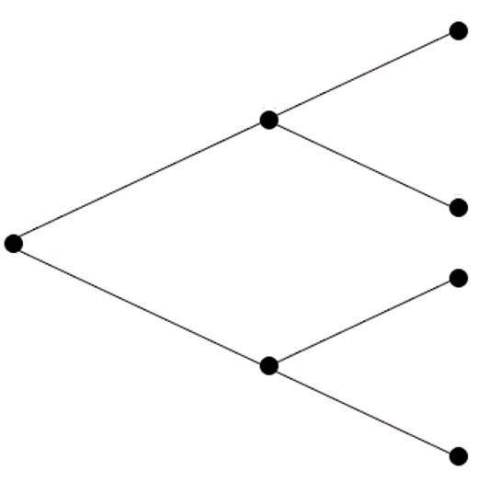
Event B is ________________________.
The complement of Event B is ________________________.
Find P(A∩B) or P(A and B). ____________________________________
Find P(A’∩B’) or P(A’ and B’). ____________________________________

Step 2: Create a chart using a town population of 10,000.
 | Positive  test result | Negative  test result | Total
Yes
(has the disease)
No
(does not have
the disease)
 |  |  | 10,000

Question
Based on the data analysis, how concerned should you be about your test results? Justify your conclusion. _________________________________
____________________________________________________________
____________________________________________________________
____________________________________________________________
____________________________________________________________

